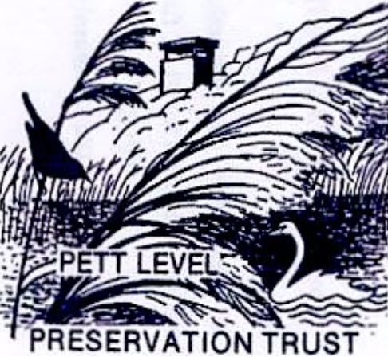

You can associate yourself with this important charity by becoming a FRIEND OF PETT LEVEL PRESERVATION TRUST in return for an annual donation of a minimum of £30.

All FRIENDS receive an annual newsletter.

If you would like to join, please complete the section below in BLOCK CAPITALS and post it to Theresa Noutch at

Theresa Noutch,
Aldershaw,
Friar's Hill,
Guestling
TN35 4ET

or email it to
theresanoutch@aol.com

Your support will be greatly appreciated and will help to ensure the continuance of this worthy cause.

[ ] Please contact me with Trust information and Newsletters

.............................................................................................................................................

Name:
Address:

Tel:
Email:

[ ] I wish to become a Friend of PLPT

Please find enclosed my annual donation of £30 (minimum £30)

Cheques to be made payable to PLPT, please.

Or you can make a bank transfer/set up a Standing Order to:

Natwest
Pett Level Preservation Trust
Account number 59677031
Sort Code 60 02 07

I will be paying by:

[ ] Cheque
[ ] Bank Transfer

Donate
You can also make a donation of any amount to PLPT using the bank details above

Our privacy statement can be found on our website www.pettlevelpreservationtrust.org

